KENTUCKY ARCHERS ASSOCIATION
553 WAINWRIGHT AVE.
LOUISVILLE, KY. 40217
f

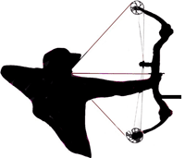
J

Meeting held @ August 8, 2020 state field held at Chickasaw archery club.

Meeting called to order at 2:00P.M. by NFAA director Glen Baxter.
Officers present: Glen Baxter, NFAA director
Frank Mosser, Treasurer
Eddie Whobrey, Field V-P.
Due to pandemic covid-19, motion made by Whobrey, seconded by Mosser to have officers remain the same for 2021. Motion passed.
Change indoor round discussed (Vegas round-5 spot). Tabled
Hall of fame nominations:
Whobrey nominated: Sylvester Bennett, Mike Westerfield, & Mark Rounds.
Baxter nominated: Courtney Campbell
Board will vote on nominations at annual meeting in November.
Agenda item: Find the High score overall field perpetual trophy
Annual meeting to be Saturday November 28 @ 12 NOON @ Chickasaw Archery Club. Pizza and drinks provided. ALL KAA members are invited to attend and participate.
Meeting adjourned 2:20 P.M.
Frank Mosser, Treasurer

